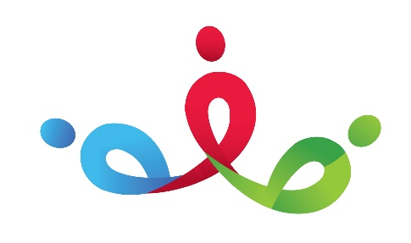

PSED

Reflect

Nursery Autumn 1

Growing UP

Literacy

Expressive Arts and Design

Talk 4 Writing- 5 Little Ducks, Owl Babies

Key Texts- Whatever Next?, Cave Baby, Monkey Puzzle, Gruffalo’s Child, Peepo

Real Life Experiences

Physical Development

Understanding of the World

Mathematics