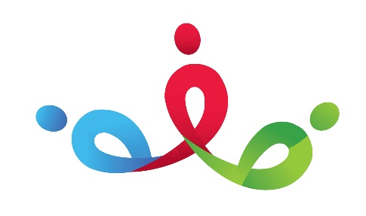

PSED

Reflect

Nursery Spring 1

Bang! Crash! Boom!

Literacy

Expressive Arts and Design

Talk 4 Writing- The Wheels on the Bus, Peace at Last

Key Texts- The Naughty Bus, Happy Hedgehog Band, Dinosaur Roar, The Rhyming Rabbit, Big Yellow Digger

Real Life Experiences

Physical Development

Understanding of the World

Mathematics